AO Trauma Seminar—
Intraoperative Imaging

October 11, 2021 | Dublin, Ireland | EVENT PROGRAM

Online pre-event assessment (by email invitation): September 15–October 10, 2021
Online post-event evaluation: October 12–November 12, 2021
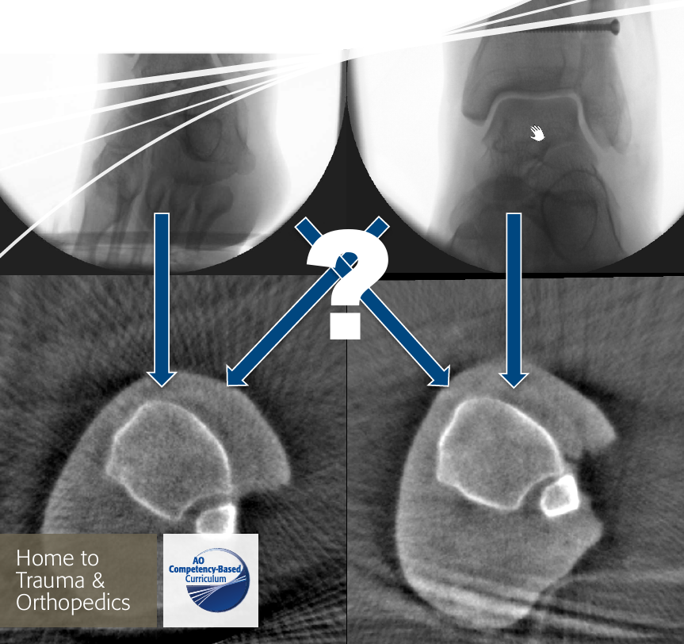
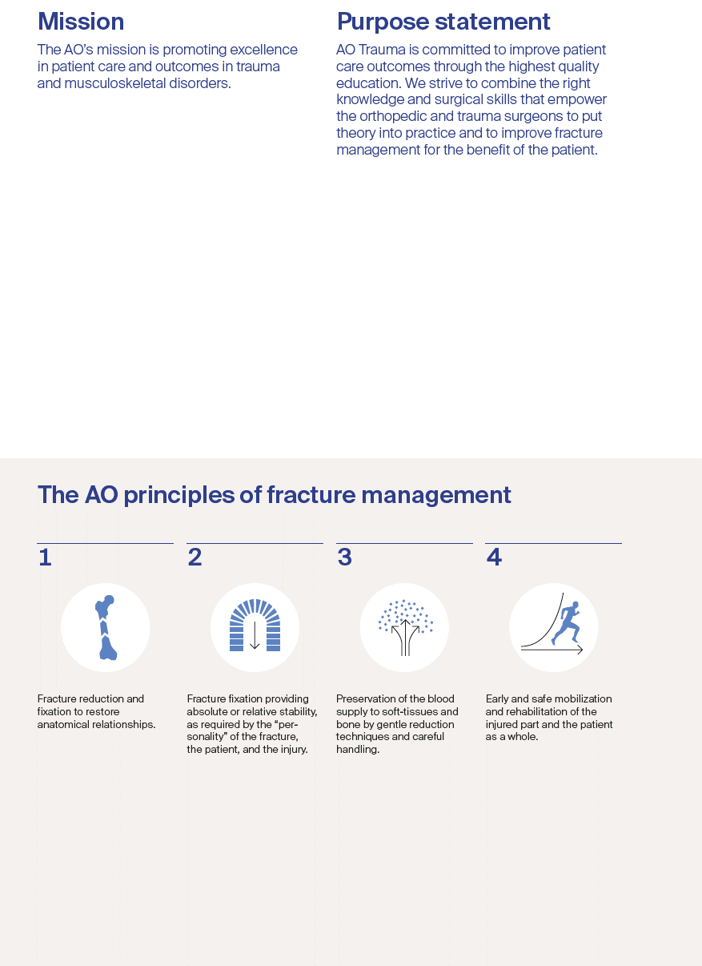
Content

2 | Mission | Purpose statement  The AO principles of fracture management
3 | Welcome
4 | Seminar description  Goal of the seminar  Target participants  Learning objectives
5 | Chairpersons | Faculty
6 | Monday, October 11, 2021
xx | Event organization  Event information and logistics
xx | General information
xx | Event venue
xx | AO Foundation—  Principles of AO educational events

Welcome
Dear AO Trauma course participant,
We are honored to welcome you to the AO Trauma Seminar—Intraoperative Imaging. We hope you will enjoy your course and the entire experience.
What is AO Trauma? We are a "clinical division"—a community for trauma and orthopedics within the AO Foundation. As a clinical division we aim to integrate and align applied and clinical research, education, and community development functions into one direction—AO Trauma for the benefit of our members, stakeholders, and patients.
How can AO Trauma benefit you? By working as a single team, we focus and leverage our resources, expertise, and skills to create and deliver new and greater value to our members.
Why join AO Trauma? Joining AO Trauma means you are part of the trauma and orthopedic community within the AO. AO Trauma will help you develop lifelong friendships and relationships. We will help you access our “knowledge network” and take part in new opportunities that advance trauma care.
Yours sincerely,

Mark Reilly  Chairperson AO Trauma  Education Commission | Michael Baumgaertner  Chairperson AO Trauma  International Board

Your experiences with us, over the next few hours, will result in the realization of new and meaningful knowledge, skills, and understanding that we hope will translate into improved patient care.

Seminar description
This highly interactive case-based seminar is based on four common fractures where specific intraoperative imaging knowledge and skills are applied. In addition, general concepts such as appropriate indications, selection of 2-D or 3-D modalities, and radiation protection will be addressed. During each case-based session, videos and small group discussions are integrated and time for questions is included.

Goal of the seminar
The AO Trauma intraoperative imaging seminar addresses the principles, techniques, and concepts related to intraoperative imaging in the treatment of common fractures and the clinical problems that may arise.

Target participants
- Surgeons at the threshold of becoming independent surgeons and taking over decision-making responsibility for the treatment of complex injuries (Advanced Principles level in AO Trauma's education).
- Surgeons in earlier years of training and all surgeons interested in imaging quality (Basic Principles level)

Learning objectives
At the end of this seminar, participants will be better able to:
- Select 2-D and 3-D intraoperative imaging modalities based on indications and limitations
- Set up the operating room (OR) for fixation of common fractures
- Perform intraoperative 2-D imaging for proximal femur, femoral shaft, ankle, and distal radial fractures
- Assess fracture reduction and implant positioning for these fractures
- Describe the indications for intraoperative 3-D imaging and review the benefits and limitations
- Decide on postoperative CT scans

Chairpersons
Brendan O'Daly  Tallaght University Hospital, Dublin, Ireland | Jochen Franke  BG Trauma Centre Ludwigshafen, Ludwigshafen, Germany

Regional Faculty
May | Cleary | University Hospital Waterford | Waterford | Ireland
Michael | Kraus | Orthix Zentrum | Augsburg | Germany
Joseph | Queally | St. James's Hospital | Dublin | Ireland
Sven | Vetter | BG Trauma Centre Ludwigshafen | Ludwigshafen | Germany

Monday
October 11, 2021
12:45–13:00 | Participant registration
13:00–13:15 | Introduction—imaging to improve patient outcomes in fracture fixation | B O'Daly, J Franke
13:15–14:00 | Case 1—Proximal femoral fracture  Open reduction and internal fixation with a nail  Learning outcomes:  - Set up the OR for proximal femoral fracture fixation, with appropriate positioning of the patient, C-arm, and personnel  - Identify anatomical landmarks on AP and lateral views and perform 2-D imaging  - Assess fracture reduction and implant positioning, with dynamic image intensification for screw position and decide if postoperative CT for evaluation is necessary | All faculty (small groups)
14:00–14:45 | Case 2—Femoral shaft fracture  Closed reduction and intramedullary nailing  Learning outcomes:  - Position the patient and C-arm appropriately for adequate viewing of the anatomical landmarks on AP and lateral views  - Use intraoperative imaging to assess fracture reduction and implant position (eg, axis, length, torsion)  - Conduct postoperative CT assessment (eg, length, torsion) | All faculty (small groups)
14:45–15:15 | Coffee break
15:15–16:00 | Case 3—Ankle fracture  Open reduction, plating of fibula  Learning outcomes:  - Evaluate reduction of upper ankle joint fractures with a syndesmotic injury  - Analyze the upper ankle joint with conventional radiography  - Recognize the benefits of 3-D image intensification in the treatment of upper ankle joint fractures | All faculty (small groups)
16:00–16:45 | Case 4—Distal radial fracture  Open reduction, volar plating, intraoperative 3-D imaging  Learning outcomes:  - Identify anatomical landmarks on standard (AP and lateral) views  - Assess fracture reduction and implant positioning, with dynamic image intensification for screw position on 2-D imaging  - Set up the OR for 3-D imaging in the treatment of distal radius fractures  - Recognize the benefits of 3-D image intensification in the treatment of distal radius fractures | All faculty (small groups)
16:45–17:00 | Questions and evaluation | B O'Daly, J Franke

Event organization
AO Trauma Education
Erna Perren
Clavadelerstrasse 8
7270 Davos Platz, Switzerland
Phone +41 79 178 92 35
Fax +41 81 414 22 84
Email: erna.perren@aofoundation.org

AO funding sources
Unrestricted educational grants from different sources are collected and pooled together centrally by the AO.
All events are planned and scheduled by local and regional AO surgeon groups based on local needs assessments. We rely on industrial/commercial partners for in-kind support to run simulations/skills training if educationally needed.

General information
Event fee
AO Trauma Seminar—Intraoperative Imaging: free of charge
Included in the seminar are the documentation, coffee break, and event certificate.

Seminar language
English

Disclosures and conflicts of interest
Disclosure information and potential conflicts of interest (COI) can be viewed at the event webpage.

Evaluation guidelines
All AO Trauma events apply the same evaluation process, which includes pre- and post-event online evaluation and on-site written questionnaires. These evaluation tools help ensure that AO Trauma continues to meet your training needs.

Intellectual property
Event materials, presentations, and case studies are the intellectual property of the event faculty.
All rights are reserved. For more information, please see: www.aofoundation.org/legal.
Recording, photographing, or copying of lectures, practical exercises, case discussions, or any course materials is absolutely forbidden.
The AO Foundation reserves the right to film, photograph, and audio record during their events. Participants must understand that in this context they may appear in these recorded materials. The AO Foundation assumes participants agree that these recorded materials may be used for AO marketing and other purposes, and made available to the public.

Security
There will be a security check at the entrance of the building. Wearing of a name tag is compulsory during lectures, practical exercises, and group discussions.

No insurance
The event organization does not take out insurance to cover any individual against accidents, theft, or other risks.

Mobile phone use
Mobile phone use is not allowed in the lecture halls and in other rooms during educational activities. Please be considerate of others by turning off your mobile phone.

Dress code
Casual or sportswear

Online resources
available at www.aotrauma.org (AO Trauma, Education, Self-directed Learning: eg, Interactive video and eLearning modules, Surgery Reference)

Event venue
College Hall
Royal College of Surgeons in Ireland
123 St Stephen's Green,
Dublin 2, D02 YN77, Ireland (Entrance of York Street)

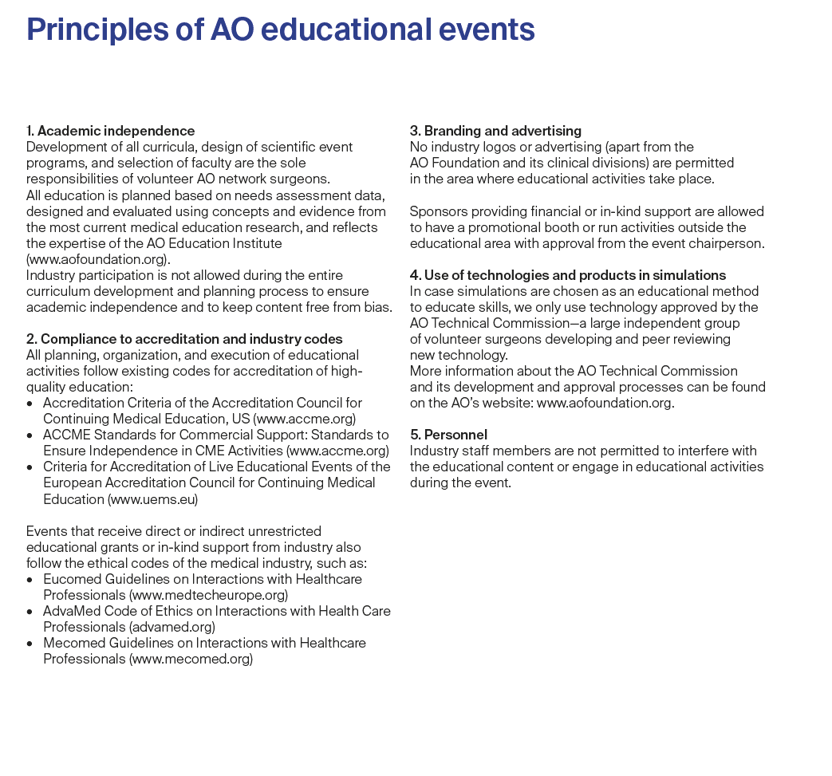
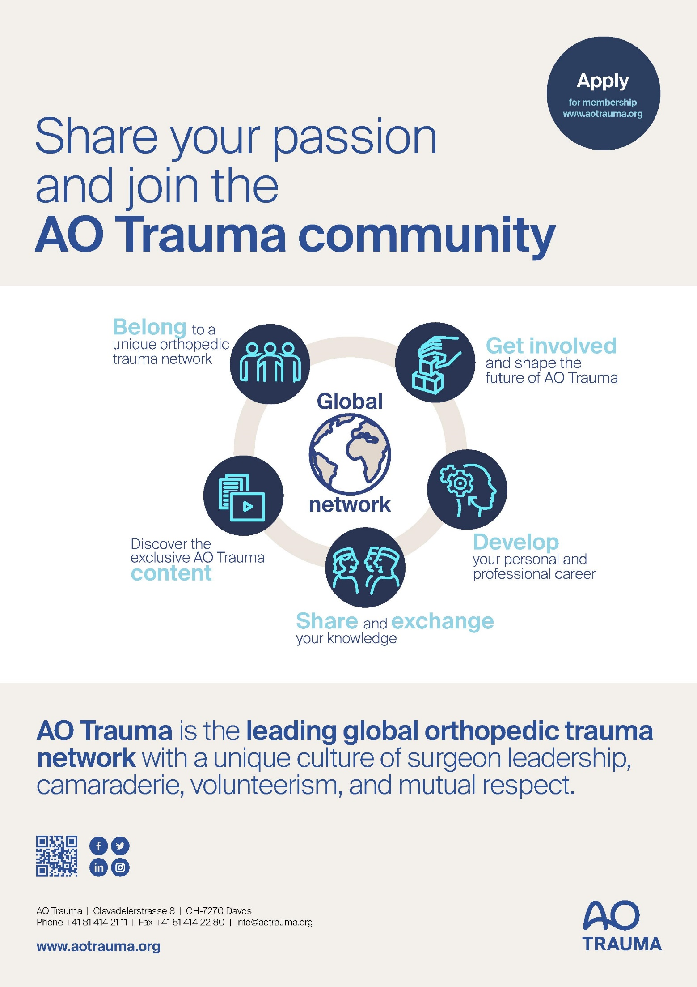
Last Page Ad

